# CS 255 System Design Document Template

This template lays out all the different sections that you need to complete for Project Two. Each section has guidance to prompt your thinking. You will need to continually reference the interview transcript as you work to make sure that you are addressing your client’s needs. There is no required length for the final document. Instead the goal is to complete each section based on what your client’s needs are. Remove this note when you are finished, and replace all bracketed text with the relevant information.

## UML Diagrams

### UML Use Case Diagram

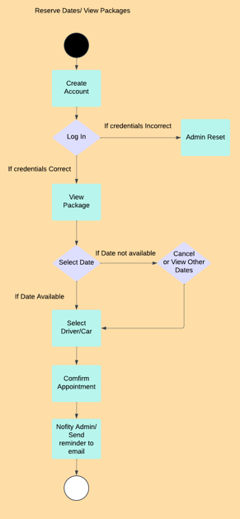

### UML Activity Diagrams

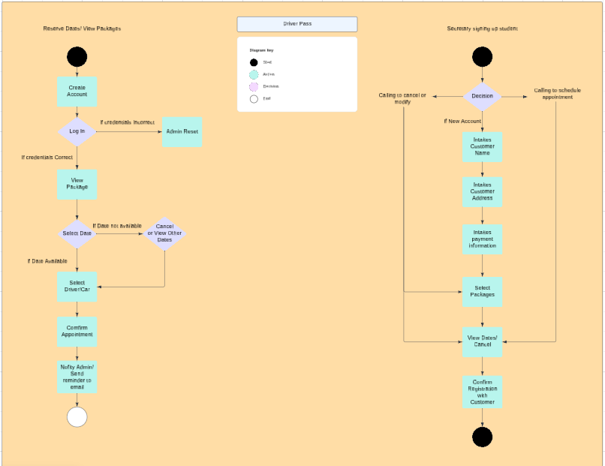

### UML Sequence Diagram

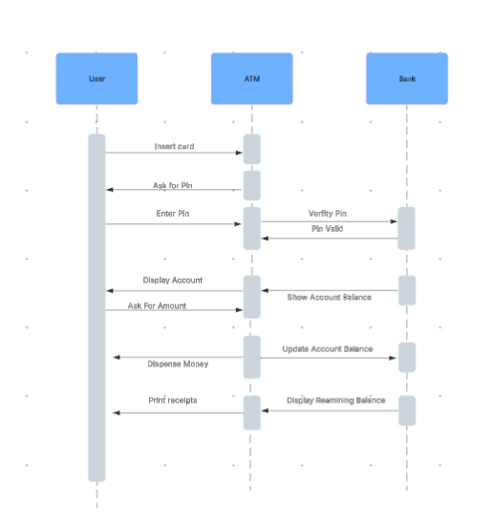

### UML Class Diagram

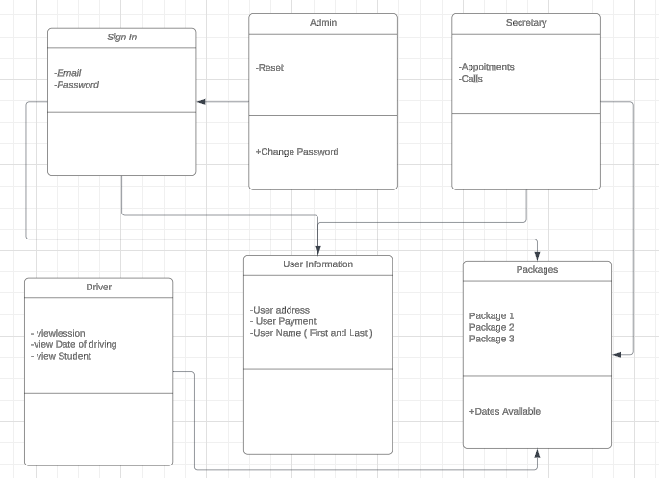

## Technical Requirements

*[Based on the diagrams you have created, describe the technical requirements of your system. These requirements should address the required hardware, software, tools, and infrastructure necessary for your system design.]*

*Based on the diagrams I provided, the system will allow users to access the DriverPass website using any smartphone. From there, users can create an account and view the available driving packages. The system requirements are minimal, with one of the primary necessities being internet access in order to connect to the server and load all content.*

*The software must run on at least iOS 8 or Android UI 5. Additionally the system relies on cloud based storage enabling the business owner to easily access and manage data remotely.*

*Regardless of hardware or software a critical technical requirement is security. Since DriverPass will handle sensitive customer data including personal and credit card information, the platform is obligated to ensure this data is well protected. Two factor authentication and the use of complex unique passwords are essential security measures.*

*To further safeguard client data against cyberattacks or system failures, regular cloud backups are required.*

*Another key system requirement is backend support. DriverPass should employ a full time developer to provide customer support and perform ongoing updates to the user interface. Frequent UI updates will help ensure users have a smooth and engaging experience when interacting with the platform.*